# Group Project Part 1b – Work to be completed with your group (60 points)

This part of the assignment to be completed by the members of your group. Collaboration with other people not in your group is not allowed. You must only work with members of your own group. The project is open book and open notes and you may use any resource at your disposal except for directly soliciting advice or input from others outside of your group. Please make sure all sources are cited. Do NOT give or share this assignment with others.

Please answer the questions listed below and submit your answers via the eLearning “Homework 1 Part 1b - Group Submission”. You may answer the questions directly in this document. Please make sure you answer all parts of each question.

The following information is used to answer the questions below.

Project Description

The new software-controlled conveyor belt is an exciting project that moves and positions items on a conveyor belt with a high degree of accuracy (< 1 millimeter of error). The proposed project will produce a new system capable of automating the movement of a wide variety of warehouse materials commonly used in order fulfillment. The following information has been developed for you to use in completing the exercises.

Assumptions and Notes **(Everyone)**

A seven-day workweek is used for the whole year. No holidays.

An 8-hour workday or 56-hour workweek is used. Overtime is not allowed.

The project should start on January 1 of the next year.

No splitting of activities is allowed.

No partial assignments are allowed (i.e. 50%). All resources must be assigned 100%.

Resources of a particular type have identical capabilities and may be substituted for each other. Hence, when working with resource type having multiple people, please create a single project resource listing (e.g. “Design”) and assign the resource a percentage value corresponding to the number of people (e.g. 200% for two people). Similarly, when working with resource types having a single person, create a single project resource listing and assign it a value of 100% to indicate a single person.

Activity durations are fixed meaning adding resources to an activity does not decrease the duration of the activity.

***Warning: Save your work frequently and make backup files as you answer each part.***

Table 1

|  |  |  |  |  |
| --- | --- | --- | --- | --- |
| **Activity** | **Description** | **Resource Type** | **Duration (days)** | **Preceding Activity** |
| 1 | System architecture | Design | 40 | - |
| 2 | Hardware specifications | Development, design | 50 | 1 |
| 3 | Kernel specifications | Design | 20 | 1 |
| 4 | Utilities Specification | Development, design | 25 | 1 |
| 5 | Hardware Design | Design, development | 70 | 2 |
| 6 | Disk drivers | Assembly, development | 90 | 3 |
| 7 | Memory management | Development | 75 | 3 |
| 8 | Operating system documentation | Design, documentation | 15 | 3 |
| 9 | Routine utilities | Development | 60 | 4 |
| 10 | Complex utilities | Development | 90 | 4 |
| 11 | Utilities documentation | Documentation, design | 10 | 4 |
| 12 | Hardware documentation | Documentation, design | 10 | 5 |
| 13 | Integration first phase | Assembly, development | 35 | 6,7,8,9,10,11,12 |
| 14 | Prototypes | Assembly, development | 65 | 13 |
| 15 | Serial I/O drivers | Development | 85 | 13 |
| 16 | System hard/software test | Assembly | 20 | 14, 15 |
| 17 | Order printed circuit boards | Purchasing | 5 | 16 |
| 18 | Network interface | Development | 25 | 16 |
| 19 | Shell | Development | 25 | 16 |
| 20 | Project documentation | Documentation, development | 20 | 16 |
| 21 | Assemble preproduction | Assembly, development | 15 | 17, lag 5 days* |
| 22 | Integrated acceptance test | Assembly, development | 20 | 18, 19, 20, 21 |

* Task 21 cannot begin until 5 days after task 17 has been completed

Table 2

|  |  |  |
| --- | --- | --- |
| **Resource Type** | **Number Available to Work on Project** | **Cost ($/hr)** |
| Design | 2 | $185 |
| Development | 2 | $115 |
| Documentation | 1 | $75 |
| Assembly/Test | 1 | $65 |
| Purchasing | 1 | $50 |

Part 1b Question 1 (30 points)

**Do not include resource assignments in your answer to Question 1. Only include activities, activity durations and dependencies.** When entering task information in Question 1, please make sure the schedule mode is set to “Manually Scheduled” instead of “Auto Scheduled” as in Figure 1. Schedule mode may be set using the “Task Information” dialog or via the “Manually Schedule” button on the “Task” ribbon. Also, please make sure the “Level Manually Scheduled Tasks” check box in the “Resource Leveling” dialog box is deselected as in Figure 2. Leveling options may be viewed using the “Leveling Options” button in the “Resource” ribbon. Both are the default settings in MS Project 2019; however, if you’ve used project for other purposes, the default settings may have been adjusted.

**Figure 1 – Initial Task Information Dialog Figure 2 – Initial Resource Leveling Dialog**

a. Create the project described in table 1 in Microsoft Project and paste a screenshot of the bar (Gantt) chart of the project highlighting the critical path below. Please make sure all tasks are clearly labeled with their corresponding task name. Your Gantt chart should also include a summary task. DO NOT INCLUDE THE RESOURCE ASSIGNMENTS LISTED IN THE THIRD COLUMN OF TABLE 1.

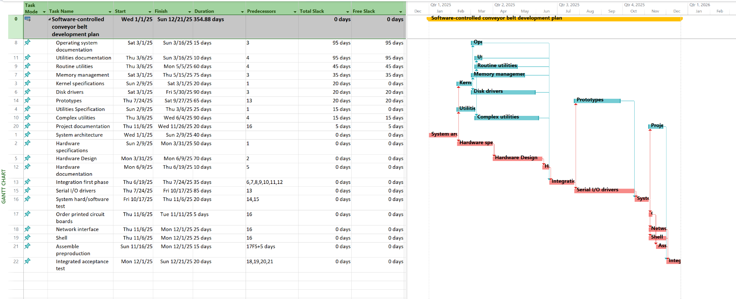

b. Include a screenshot out of early start, late start, early finish, late finish, total slack and free slack in table form. The screenshot provided should also include a summary task for the project.

c. How many days will the project take to complete?

**355 days (354.88 days)**

d. What is the scheduled finish date?

**Sun 12/21/25**

e. What percent of project activities are on the critical path?

Activities on Critical path: 12

Total Activities: 22

Percent of project activities on the critical path: **54.54 %**

f. What activity has the most total slack? What activity has the most free slack? Explain the difference between free slack and total slack.

Activity with the most total slack: **Operating system documentation & Utilities documentation**

Activity with the most free slack: **Operating system documentation & Utilities documentation**

Difference between free slack and total slack:

**Free slack**: The free slack of an activity is the amount of time that a task can be delayed without delaying any successor tasks.

**Total slack:** The total slack of an activity is the amount of time that an activity can be delayed without impact on the finish date of the project.

g. What is the total slack for the project as a whole? Use the summary task to help answer this question.

**Total Slack: 0**

h. Is it better to have a higher percentage of activities on the critical path or a lower percentage of activities on the critical path? Explain your answer.

A lower percentage is preferable. A higher percentage results in an increased risk of scheduled days. Critical activities are whether a late start or finish will push back the project completion date. More critical activities means an increased chance of one of them pushing back the project completion date if late.

Part 1b - Question 2 (30 points)

Using the project you created in question 1, assign resources to perform each activity. The project is limited to the resources listed in Table 2. All scheduled activities must include a list of resource commitments.

a. After assigning resources, what is the cost of the project?

**$1,207,600.00**

b. Which, if any, of the resources are over-allocated? List the resources that are over-allocated.

|  |
| --- |
| Over-allocated Resource Name |
| **Design** |
| **Development** |
| **Documentation** |

c. For each over-allocated resource, by how many hours is the resource type overallocated? Your answer should be a single number for each overallocated resource type. For example, if Purchasing is over-allocated, you need to determine by how many hours it is over-allocated and provide the answer (e.g. Purchasing is over-allocated by 50 hours). Assume a 56 hour work week and that you are evaluating over-allocations on a week by week basis.

**So, Design is over-allocated by 264 hrs**

**Development is over-allocated by 2048 hrs**

**Documentation is over-allocated by 76 hrs**

d. Try to resolve the over-allocation problems without extending the duration of the project using the resource leveling feature of MS Project. To level resources without extending the duration of the project, make sure the check boxes for “Level only within available slack” and “Level manually scheduled tasks” are both selected. Also, assume “Leveling can adjust individual assignments on task”, “Leveling can create splits in remaining work”, and “Level resources with the proposed booking type” are deselected. See Figure 3 for the correct leveling settings? Which, if any, of the over-allocated resources are no longer over-allocated? Which, if any, of the resources are still over-allocated?

**Figure 3 – Resource Leveling Dialog for question 2d**

The over-allocated resource **Documentation** is no longer over-allocated after resource levelling. **Design and Development** are still over-allocated.

e. **Include a Gantt chart and schedule table after leveling only within available slack. Please include a summary task and make sure all tasks are clearly labeled with their corresponding task name.**

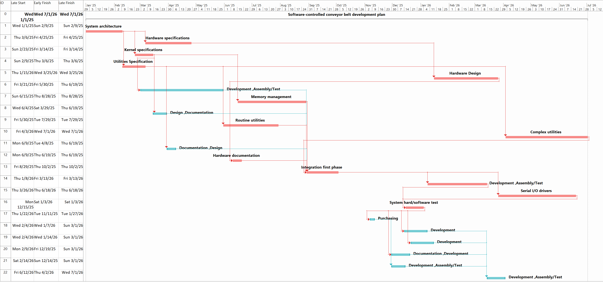

**Omkar**

f. What is the impact of leveling within slack on the percent of project activities on the critical path?

The number of activities on the critical path has **increased**.

Activities on Critical path: 19

Total Activities: 22

Percent of project activities on the critical path: **86.36% (31.82 %increase)**

g. Assume you cannot add additional resources and the project is resource constrained. How many days will the project take after resolving all over-allocation problems? What is the scheduled finish date?

See Figure 4 for the correct leveling settings. After leveling your project, change the scheduling mode for all tasks to “Auto Schedule” and review all tasks in the project to ensure no problems exist.

**Figure 4 – Resource Leveling Dialog for Question 2g**

Project will take **547 days and end on 7/1/26** after all over-allocation has been leveled.

h. How does the schedule in 2g compare to the schedule in Question 1? Why did the number of days to complete the project in 2f increase?

Project duration increased to 547 days. The days increased due to resource leveling. Now, no days have an overallocation of resources beyond the max capacity based on table 2. Therefore, the tasks were adjusted based on the necessary resources to complete the task within the resource capacity constraints. The number of tasks on the critical path has also decreased since we are not trying to fit every task with the available slack. This has reduced the risk but the timeline for the project has increased.

i. What is the total cost of the project after resolving all over-allocation problems in step 2f? How does this cost compare with the cost in 2a? What is the formula used to calculate the total cost of the project listed in the summary task? In other words, how would you calculate the total cost of the project manually using Excel? Be specific in your response clearly indicating each cost component.

Total cost of the project is $1,207,600. The total costs are the same since only durations were adjusted as the total resource allocation remained the same.

From [MS Support page](https://support.microsoft.com/en-us/office/cost-fields-c9ddf12c-8396-49e4-8edd-07aebd862f10#:~:text=As%20actual%20work%20or%20actual%20cost%20is%20reported%20on%20the,cost%20to%20the%20remaining%20cost.&text=Cost%20is%20calculated%20from%20the,the%20resource%20for%20the%20task.)

Cost = Actual Cost + Remaining Cost.

Actual cost = ((actual value work done *std rate of assigned resource) + actual fixed cost).

Remaining cost = ((remaining work to be done * std rate of assigned resource) + remaining Fixed costs).

In our case, if we would have to do it manually we would do the following:

For each task:

Cost = {For each resource assigned:

Work * Resource Std. Rate

}

Add up all the costs to get **Total Project Cost**.

j. Fill in the details in the table below with the number of hours worked by each resource type over the life of the project and the total cost for each resource type over the life of the project. Which resource type has the greatest cost? What is the formula for calculating the total cost of a resource type?

|  |  |  |  |
| --- | --- | --- | --- |
| **Resource Type** | **Total Hours Worked Over the Life of the Project** | **Hourly Rate** | **Total Cost of Resource Type** |
| Design | 1,920 | $185/hr | $355,200 |
| Development | 6,000 | $115/hr | $690,000 |
| Documentation | 440 | $75/hr | $33,000 |
| Assembly/Test | 1,960 | $65/hr | $127,400 |
| Purchasing | 40 | $50/hr | $2,000 |

FORMULA: Total hours worked X Hourly Rate to get TOTAL of resource type

**Development** has long hours and a high hourly rate; therefore, this resource type costs the most out of all 5 with total cost of $690,000

Part 1b – Team Member Contributions (0 to -100)

List and briefly describe the contribution of each team member on this assignment. The description for each team member should be one or two sentences at most. The primary purpose of this section is to identify someone who did not participate or contribute to the group project. You will also have an opportunity to provide detailed feedback on group member performance later in the semester.